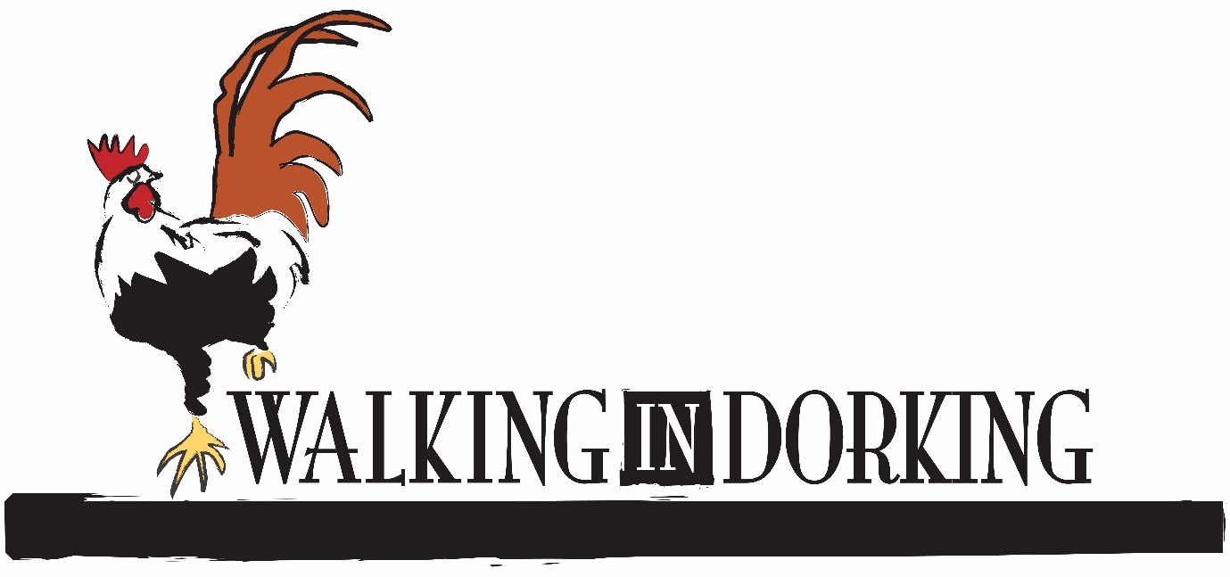'Walking in Dorking' Pub Walk
Confirmation of Booking
We look forward to welcoming you to 'Walking in Dorking'!
Practical information - please read carefully

- Please meet your guide outside Dorking Museum on West Street. The Museum is situated on the alley running off West Street between Pump Corner and the United Reformed Church.
- The walk is conducted on paved surfaces but there are some steep inclines in the town. We advise walkers to wear suitable footwear for walking.
- There are toilet facilities on the walk; please ask your guide.
- Parking is available in car parks on West Street, North Street, behind Sainsbury's on the High Street, and behind St Martin's Walk shopping centre.
- Walks last approximately an hour and a half at a moderate walking pace.
- We only ever collect personal information that we need. When we ask you to provide your personal information, we let you know why we are asking and how we will use the data. We may need to use your personal data in order to contact you in the event of event cancellation. For further information please read our privacy policy on our website at https://www.dorkingmuseum.org.uk/privacy-notice/
- We welcome feedback (positive and negative) on our walks and welcome photos. If you have enjoyed your walk, please leave feedback on Facebook.

